Part #1: Sign Up for Tools 1
Step 1.1: Airtable 1
Step 1.2: Make 1
Step 1.3: OpenAI 1
Part #2: Establish Airtable-Make Connection 2
Step 2.1: Add a “Button” field (column) on Airtable 2
Step 2.2: Connect Airtable with Make via Webhook 2
Part #3: Set The AI Module & Save Output 3
Step 3.1: Add OpenAI Module 3
Step 3.2: Save AI Output on Airtable 4
Alternative Approach To Airtable-Make Connection 4
Code Snippet for “Run a script” Action 4
A Song For Our Automation Journey 5
Part #1: Sign Up for Tools
Step 1.1: Airtable
- 
Go to this link: https://airtable.com/appnpoN3m6JjWv2SY/shr7dXmWC20KS4JQx
Click “Copy base” in the top left corner
Sign up for a free Airtable account [If you don’t have one]
Pricing page: https://airtable.com/pricing
Open the copied base on your account
Step 1.2: Make
Sign up for a free account here: https://www.make.com/en/register
Step 1.3: OpenAI
Sign up here: https://platform.openai.com/docs/overview
Add your payment method and add $5 USD to credit balance here: https://platform.openai.com/settings/organization/billing/overview

Part #2: Establish Airtable-Make Connection
Step 2.1: Add a “Button” field (column) on Airtable
Name: “Social Button”
Label: “Generate!”
Action: “Open URL”
URL formula: "URL?record_id=" & RECORD_ID()
ChatGPT could help with the following prompt:
“CONTEXT: I'm using "Button" field on Airtable. Whenever I click the button it should open a webhook URL and pass on an Airtable record id.
YOUR TASK: Write an Airtable formula for Airtable "Button" field "URL formula" section.”
Step 2.2: Connect Airtable with Make via Webhook
Go to your account on Make
Click “+ Create a new scenario” button at the top left corner
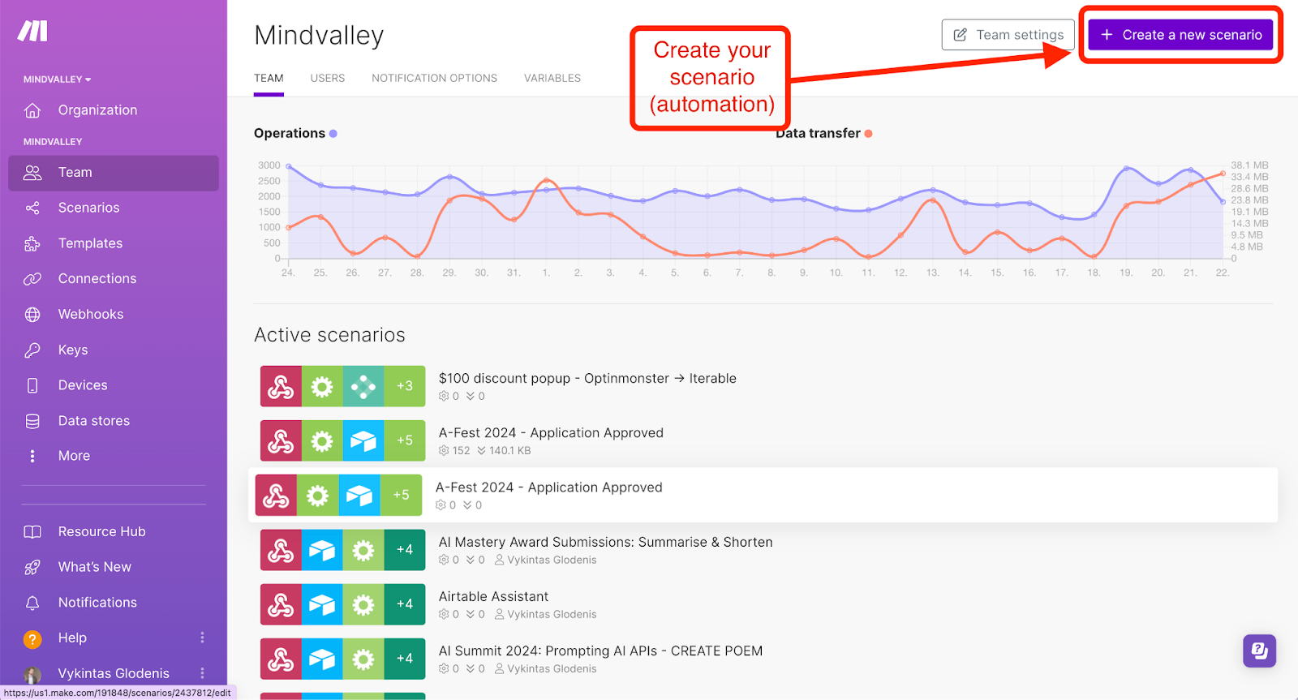
Click the big “+” button to add a trigger (1st module of the automation)
Type in “Webhooks” to search for the right module
Select “Custom webhook”
Click “Add” under the “Webhook” section
Enter any name under “Webhook name”
Click “Save”
Before you close the module—click the grey button “Copy address to clipboard”
Go to Airtable to finalise your “Social Button” field
Double click on your button field (column) name to open field editing/setting panel (or click the arrow next to field name and then “Edit field”)
Copy paste your webhook URL instead of the “URL” string in the “URL formula”
Click “Save”
Back on Make—right click on the “Custom webhook” module
Click “Run this module only” (to test the integration)
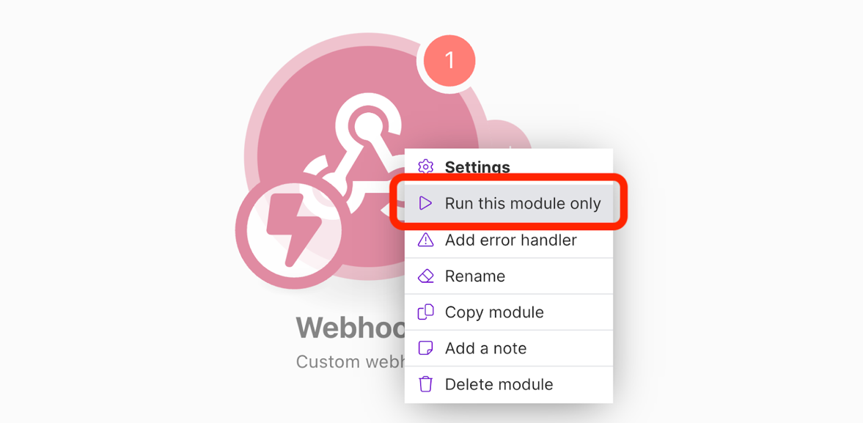
Go to Airtable and click the “Generate!” button under any of record (row)
Check if your “Custom webhook” module has been triggered successfully
Click “+” to add a new (2nd) module on your Make scenario
Type in “Airtable” in the search
Select “Get a record”
Establish your Airtable connection on Make
Click “Add” under “Connection” > “Airtable Token or Key”
For “Personal Access Token” go to https://airtable.com/create/tokens > “+ Create new token”
Fill in “Name”
Set up “Scopes” (select everything under “Record Data and Comments” and everything under “Base Schema”
Under “Access”—select “All current and future bases in all current and future workspaces”
Select the “Base” + Map airtable record ID to the variable you received from webhook
Part #3: Set The AI Module & Save Output
Step 3.1: Add OpenAI Module
Click “+” to add a new (3rd) module on your Make scenario
Type in “OpenAI” in search
Select “Create a Completion (Prompt) (GPT-3, GPT-3.5, GPT-4)”
Click “Add” to establish connection to your OpenAI account
Create API key on https://platform.openai.com/api-keys
Find Organization ID on https://platform.openai.com/settings/organization/general
Model: GPT-4o (System)
Max Tokens: 0
A number 0 means that you don’t set any limit for the response length
Messages:
Message 1
Role: System
Message: Extract one interesting idea from this article content and create an inspiring social media post.
Message 2
Role: User
Message:
TITLE: {Map to “Title” variable}
CONTENT: {Map to “Content” variable}
Click Save
Step 3.2: Save AI Output on Airtable
Click “+” to add a new (4th) module on your Make scenario
Type in “Airtable” in search
Select “Update a Record”
Select Base
Select Table
Map to “record_id” variable under “Record ID”
Save AI output under “Post Content”
Map by referring to the variable from the previous (AI) step: “Choices []” > “Message” > “Content”
Test Automation
Save Make scenario
Click “Run once” (button in the lower left corner)
Go to Airtable and click “Generate!” button next to any of the records (rows) you want to create a social media post for

Alternative Approach To Airtable-Make Connection
Note connecting via an Airtable automation “Run a script” module requires a paid account.
Code Snippet for “Run a script” Action

let config = input.config();
let url = `URL?record_id=${config.record_id}`;
fetch(url);

A Song For Our Automation Journey
Link to download the song: https://drive.google.com/file/d/194LlFfN7ymCYqZLXHu8EzJMVZUWgbkr7/view?usp=sharing

Lyrics:

[Verse]
Thought I needed a genius, or a coder in sight,
But I found OpenAI, it's my digital knight,
ChatGPT's got my back, answering all day,
Life's on easy street, automation's the way.

[Verse 2]
Airtable's handy, keeps me in line,
I got every detail, color-coded to shine,
Make.com next, we’re linking things up,
From chores to work, it's all a simple setup.

[Chorus]
Automate, navigate, no-code's our friend,
From sunrise to moonlight, the ease never ends,
AI's in the saddle, riding through the night,
Automating life, everything's alright.

[Verse 3]
Bills on autopilot, chores on a spree,
With just a few clicks, I'm living stress-free,
Emails write themselves, as pretty as can be,
Thanks to automation, I'm finally free.

[Verse 4]
Morning coffee brews with a single command,
Schedules align like the best marching band,
Didn't think tech could give me its hand,
But here I am, livin' off the AI land.

[Chorus]
Automate, navigate, no-code's our friend,
From sunrise to moonlight, the ease never ends,
AI's in the saddle, riding through the night,
Automating life, everything's alright.

